Calculus I Name Ans Key
Washers Worksheet (B) Block Date

#1-4 Set up the integrals but do not calculate the volume.
#5-8 Set up and calculate the volume. (A graphing calculator may be used to find the volume).

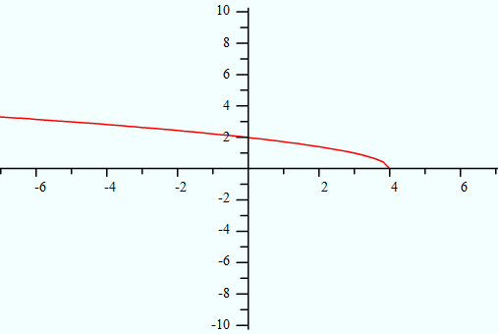
1.
a) x – axis
b) y – axis
c) y = 3

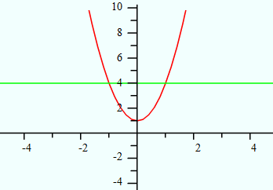
2.
a) x – axis

b) y = 4

c) y = 6

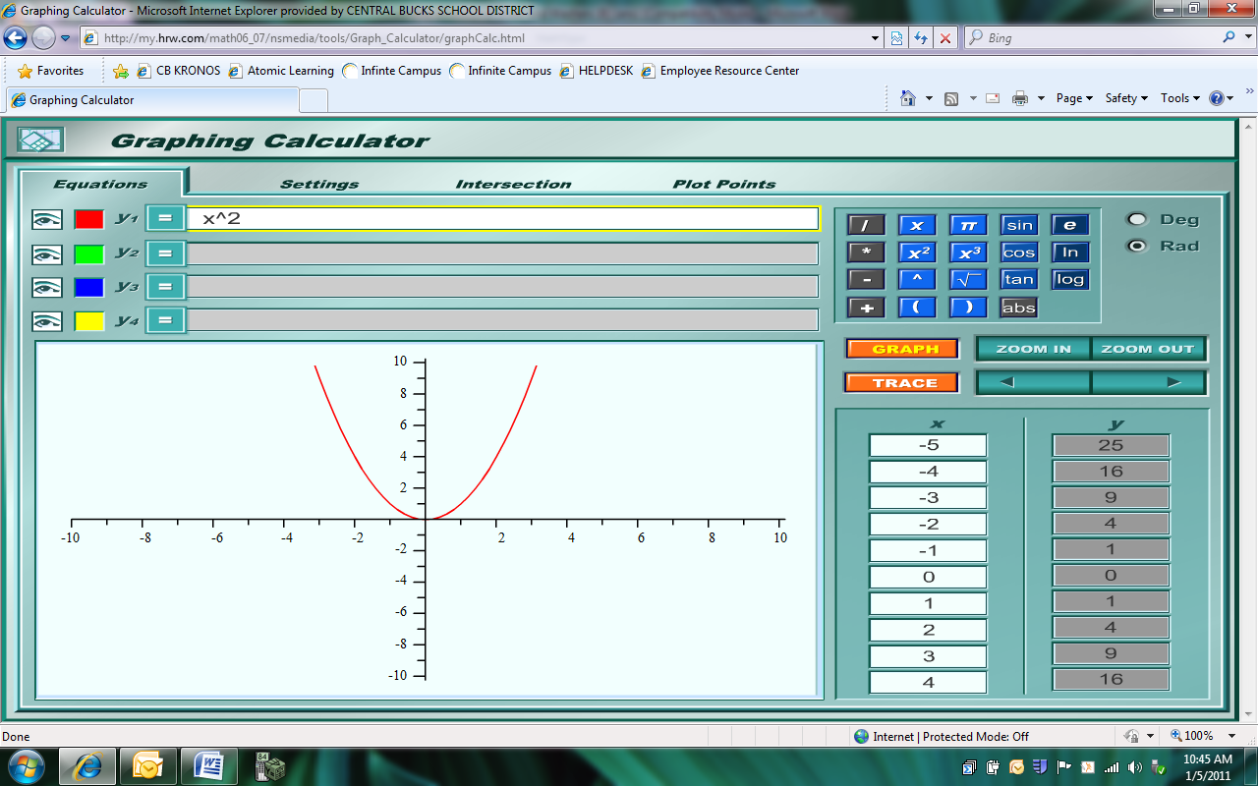
3.
a) x – axis
b) y – axis
c) x = 2
d) x =-1
e) y=-1
4.
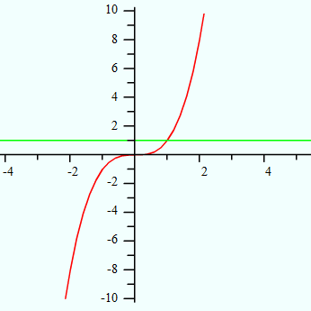
a) x = 2
b) x = -2
c) y = 2
d) y = -2
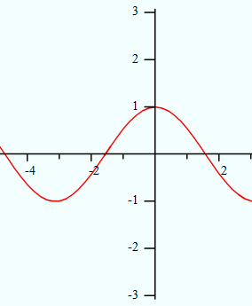
5.

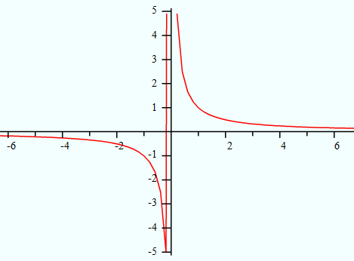
6.

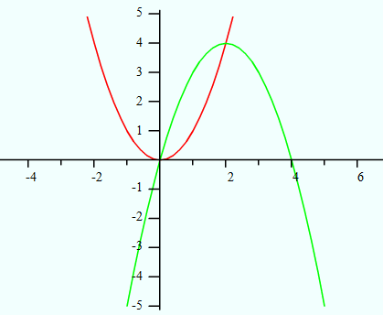
7.
a) x – axis
b) y = 6
8.
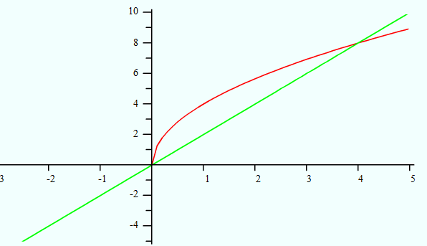
a) x – axis
b) y – axis
c) y = -1
d) x = 4

